Lab Exercise 8– Creating Service in Kubernetes
Below is a lab exercise that will help you understand and practice creating a service in Kubernetes:
Task 1: Start Kubernetes in Docker-Desktop
- Start Kubernetes service in Docker-Desktop
Task 2: Creating a Service
Create a service to expose the deployed application within the Kubernetes cluster. You can use the following sample YAML manifest as a reference:

apiVersion: v1
kind: Service
metadata:
name: my-service
spec:
selector:
app: lbnginx
ports:
- protocol: TCP
port: 80
nodePort: 30001
type: NodePor
- Apply the service using the following command:
kubectl apply -f service.yaml
- Verify that the service is created by running the following command:
kubectl get services
Output -
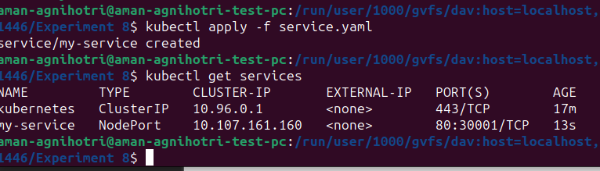
Task 4: Accessing the Service
- Access the service using port forwarding. Run the following command:
Access the Nginx server running in the service by opening a web browser and navigating to
http://localhost:8080/

Or Access the Node using the Minikube IP

http://<minikube-ip>:30001
Output -
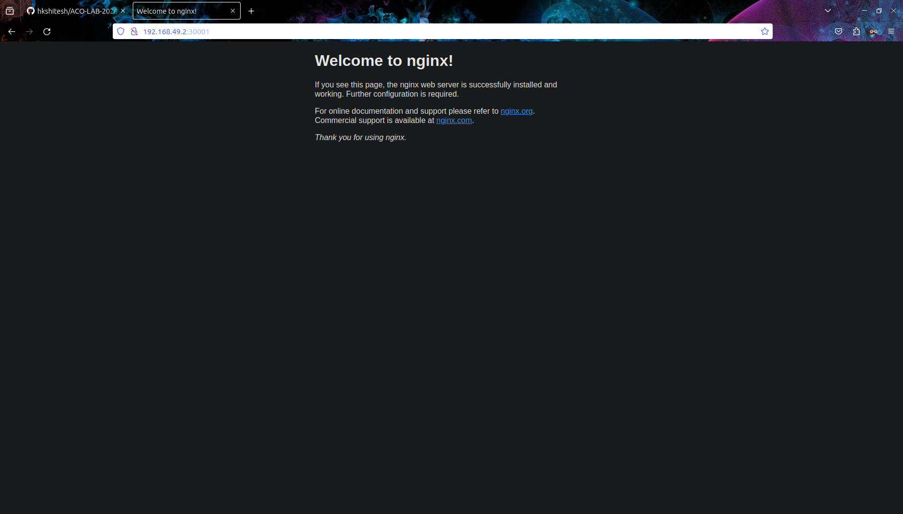

Task 5: Deleting the Service
Delete the service using the following command:
kubectl delete service my-service
Verify that the service has been deleted by running the kubectl get services command.
Output -
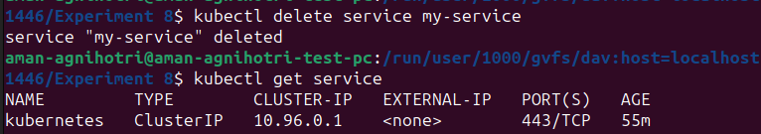
Task 6: Cleanup
Delete any remaining deployments, services, and resources created during the exercise using the appropriate kubectl delete commands.
Task 7: Documentation and Best Practices
Document your findings and the best practices for creating and managing services in Kubernetes.
Through this exercise, you'll gain a better understanding of how to create and manage services to expose applications within a Kubernetes cluster. Adjust the exercise based on your specific use case and requirements.

